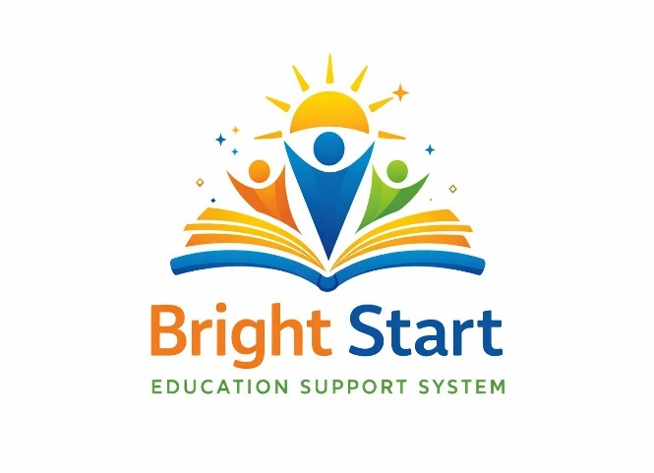
BRIGHT START EDUCATION SUPPORT SYSTEM
Task 1: Project Plan
_______________________________________________
Submitted by:
Keabetswe Modiba (Project Manager/Leader) -ST10438507
Chantal Mafa (Systems Analyst)-ST10444319
Dennis Moima (QA Tester) ST10451932
Kgothatso Magatsela (Developer)ST10448288
2026

TABLE OF CONTENTS
Contents
1. Introduction 4
1.1 Customer Needs 4
1.2 Goals and Objectives 4
1.3 Budget 4
1.4 Risks 4
1.5 Benefits 4
2. Milestones and Deliverables 5
A) Project Initiation and Approval 5
B) Requirements Analysis 5
C) System Analysis 5
D) System Design and Architecture 5
E) System Development and Implementation 6
F) System Testing and Quality Assurance 6
G) System Deployment and User Training 6
H) Project Closure and Final Documentation 6
3. Work Breakdown Structure 7
WBS Hierarchical Diagram 7
WBS Task Table 8
4. Gantt Chart and Interpretation 9
Gantt Chart 9
Gantt Chart Interpretation 9
5. Risk Management 10
Risk Register 10
6. Technical Feasibility 11
6.1 Hardware Resources 11
Availability and Solutions 11
6.2 Software Resources 11
Availability and Solutions 11
7. Economic Feasibility 13
Project Cost Breakdown 13
8. Team Members 14
Profile Summary 14
Education 14
Skills 14
Project Responsibilities 14
References 15
Profile Summary 15
Education 15
Skills 15
Project Responsibilities 15
References 15
Profile Summary 16
Education 16
Skills 16
Project Responsibilities 17
References 17
Profile Summary 17
Education 17
Skills 17
Project Responsibilities 18
References 18
Appendix 18
References 18

1. Introduction
Bright Start Education Initiative is a non-profit organization focused on improving access to education for underprivileged learners in rural and disadvantaged communities. Many students in these areas face barriers such as lack of learning resources, limited access to qualified teachers, and poor technological infrastructure. To overcome these challenges, the organization plans to develop a digital management system called the Bright Start Education Support System. The system will help the NGO manage students, volunteers, educational programs, donations, and progress reports more efficiently.

1.1 Customer Needs
The main need of the management team is a centralized platform that enables them to track students, coordinate volunteer teachers, manage educational programs, and monitor the progress of learners. The majority of the organization's work is currently handled manually using spreadsheets and paper records, leading to inefficiencies, data loss, and difficulty in tracking the impact of programs. The new system will simplify these processes and provide accurate data for decision-making.

1.2 Goals and Objectives
The project's main objectives are to develop a reliable, user-friendly system that can store and manage student information, track volunteer activities, record donations, and generate reports for stakeholders and sponsors (Contributors, 2023). The system will also help administrators schedule tutoring sessions, monitor student performance, and communicate effectively with volunteers and donors. By digitizing these processes, the organisation will be able to improve operational efficiency and increase the reach of its educational programs. This project will be completed in approximately 50 days (1 day = 8 hours).

1.3 Budget
Because the organization runs on a small budget supported by grants and donations, cost restrictions are an important factor to consider. The project must therefore use affordable technologies. Development will be completed using affordable software tools and existing hardware resources to minimise expenses. The team must ensure that development stays within the allocated budget of R62 370 while still delivering a functional and high-quality system.

1.4 Risks
There are several risks associated with the project. If the project is delayed or exceeds its budget, the organisation may struggle to implement the system in time for upcoming educational programs. There is also a chance that team members may not have the necessary skills, or that requirements may change during development. If the system fails to meet user needs, the NGO may continue to rely on inefficient manual processes.

1.5 Benefits
If the project is successful, the benefits for the customer will be significant. The NGO will gain an organized and efficient platform for managing educational initiatives. Employees will be able to manage student progress, coordinate volunteers, and manage resources more effectively. Additionally, the system will help the organization demonstrate its impact to donors and sponsors, increasing the chances of receiving future funding and expanding its educational programs.

2. Milestones and Deliverables
Projects usually follow structured phases such as initiation, planning, execution, and closure. The following milestones and their associated deliverables define the key phases of the project (Sante Delle- Vergini & Douglas Eacersall, 2023). Each milestone represents a major stage in the development of the Bright Start Education Support System.

A) Project Initiation and Approval
Official start of the project. During this phase the project objectives, scope, stakeholders, and expected outcomes are defined. The NGO management needs to approve before proceeding.
Deliverables:
- Project proposal document
- Project scope
- Stakeholder identification report
- Project approval confirmation from NGO management

B) Requirements Analysis
In this stage, the project team gathers and analyzes requirements from the management and program coordinators. The objective is to understand the operational needs of the organization and determine what features the system must provide.
Deliverables:
- Requirements gathering report
- Functional requirements specification
- Non-functional requirements specification
- Use case descriptions for system users (students, admin and volunteers)

C) System Analysis
The collected requirements are analyzed to determine how the system will operate. The project team identifies how technology can improve efficiency.
Deliverables:
- System analysis report
- Business process diagrams
- System requirement specification (SRS) document
- Data flow diagrams showing how information moves through the system

D) System Design and Architecture
The design structure of the Bright Start Education Support System includes the database structure, system architecture, and the layout of user interfaces.
Deliverables:
- System architecture diagram
- Database design (Entity Relationship Diagram - ERD)
- User interface wireframes or prototypes
- System design specification document

E) System Development and Implementation
The development team begins coding the system and building the database. Core functionalities such as student registration, volunteer management, program scheduling, and donation tracking are implemented.
Deliverables:
- Working system modules
- Integrated database system
- Functional prototype of the NGO management system
- Source code repository (GitHub)

F) System Testing and Quality Assurance
The developed system is tested to ensure that it meets the specified requirements. Testing includes checking functionality, performance, usability, and security.
Deliverables:
- Test plan document
- Test case documentation
- System testing report
- Bug/issue tracking report and resolved errors

G) System Deployment and User Training
The system is deployed for use by the NGO after successful testing. Staff is then trained on how to operate the system and manage its features effectively.
Deliverables:
- Deployed Bright Start Education Support System
- User training materials and guides
- System installation documentation
- Initial user feedback report

H) Project Closure and Final Documentation
This phase marks the completion of the project. Final documentation is prepared and delivered to the NGO management for future reference and system maintenance.
Deliverables:
- Final project report
- System user manual
- Technical documentation
- Project evaluation and closure report

3. Work Breakdown Structure
The Work Breakdown Structure (WBS) provides a hierarchical decomposition of all project tasks. Each task is described with its duration, predecessor, responsible team member, and required resources.

WBS Hierarchical Diagram
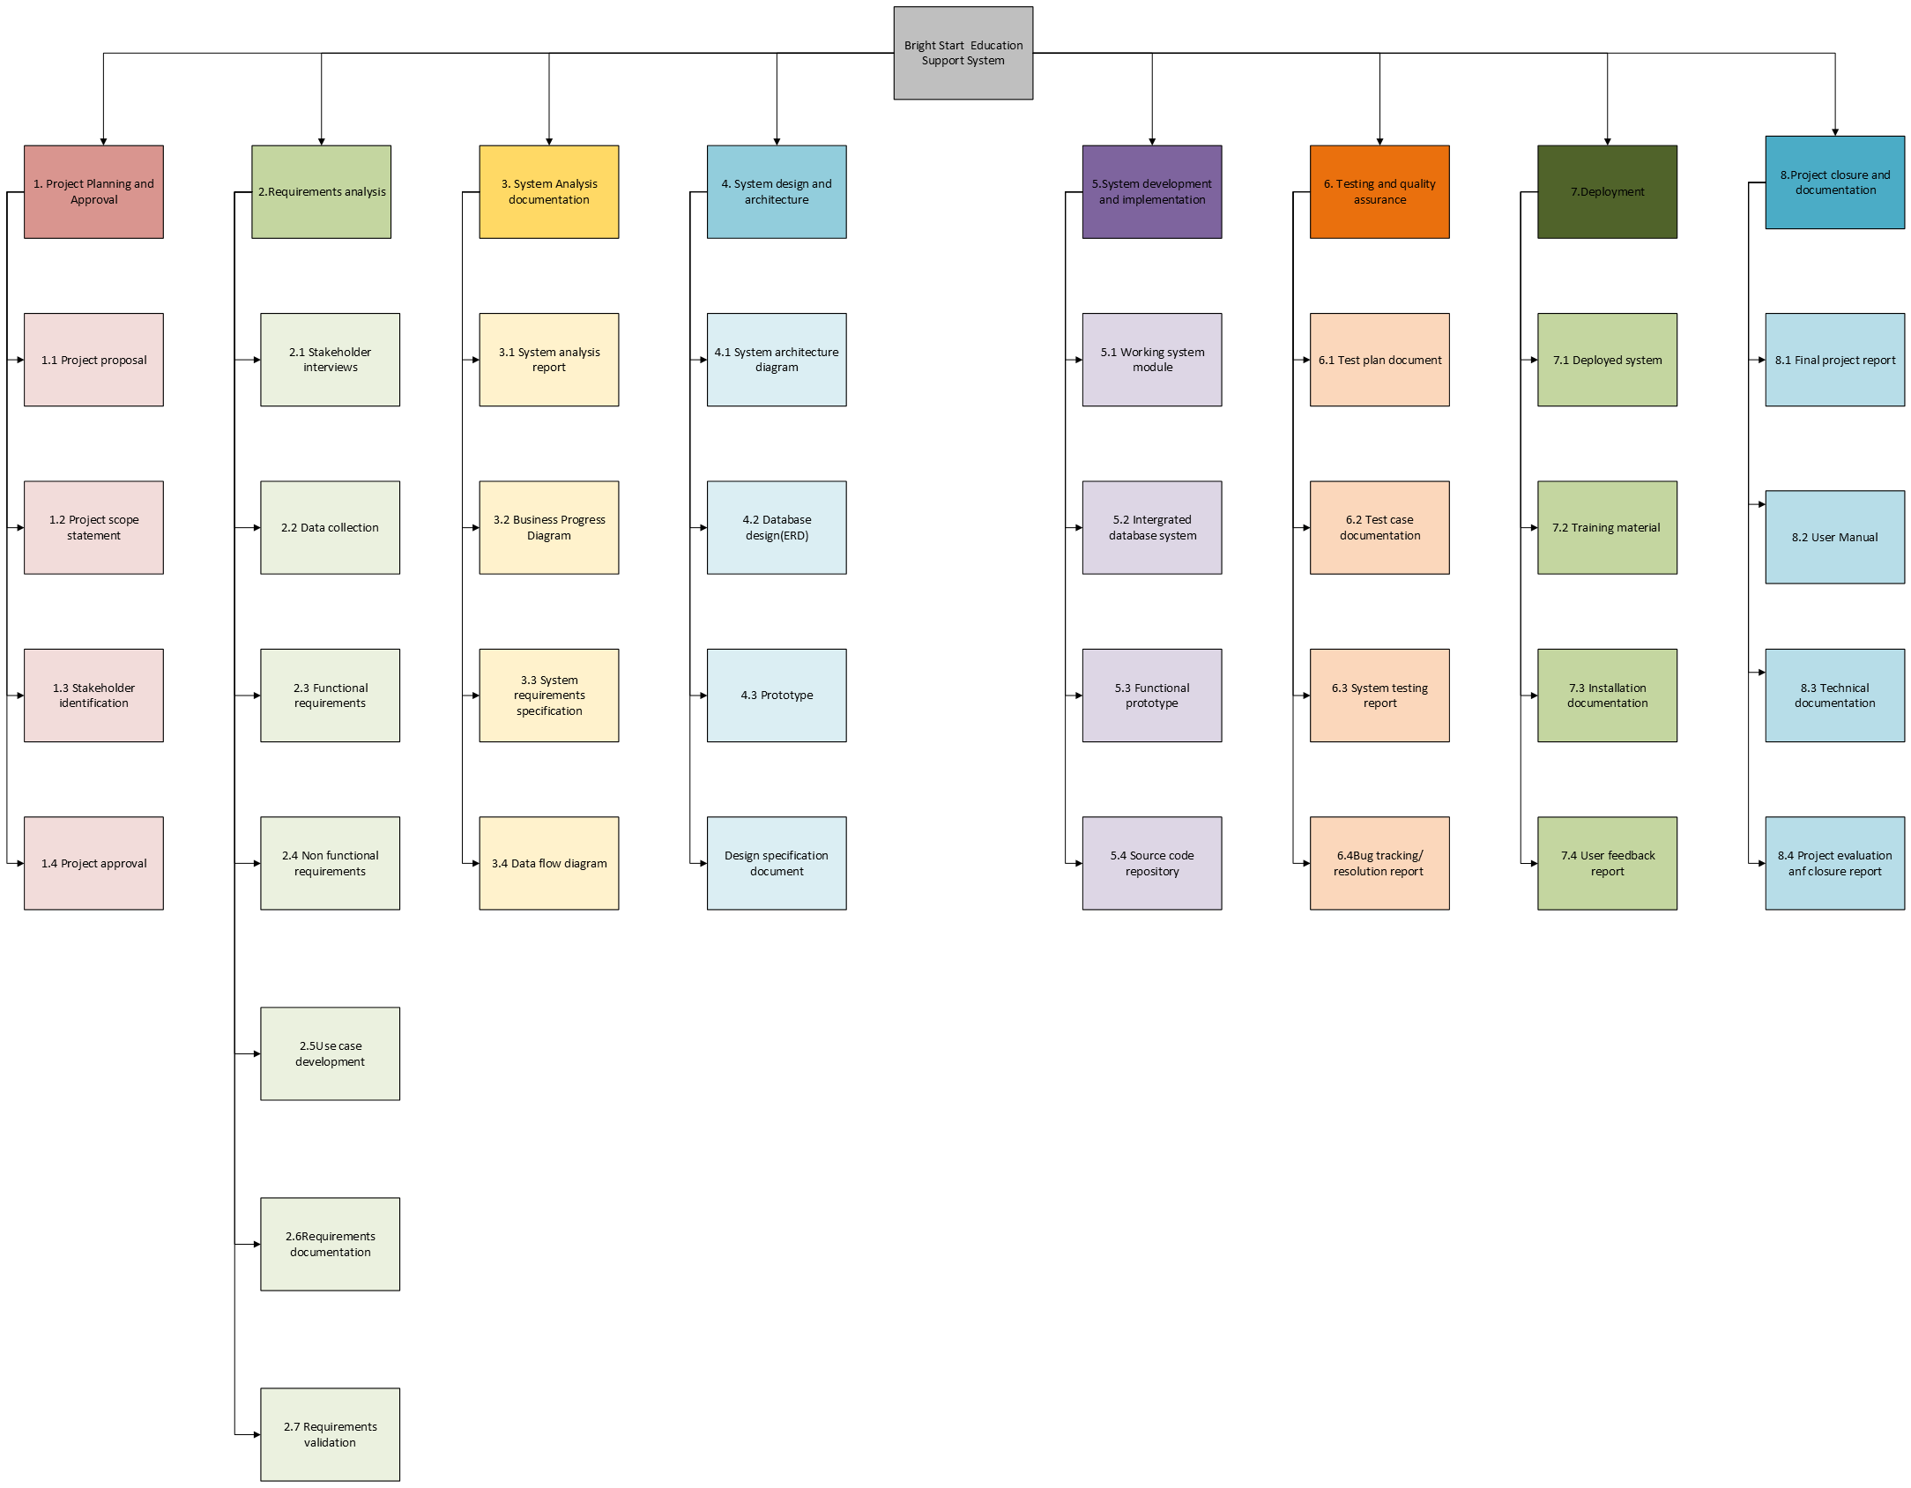
Work Breakdown Structure – Hierarchical Diagram

WBS Task Table
Task ID | Task Name | Description | Time Allocation (hrs) | Predecessor | Responsible Member | Resources
1.0 | Project Planning | Define scope and timeline | 30 Hours | None | Project Manager | MS Word
2.0 | Requirements Gathering | Collect requirements from organisation staff | 72 Hours | 1.0 | System Analyst | Interview forms
3.0 | System Analysis | Analyse requirements and define system processes | 30 Hours | 2.0 | System Analyst | Documentation tool
4.0 | System Design | Design system architecture and database | 25 Hours | 3.0 | System Designer | Design software
5.0 | Database Development | Create database for stakeholders | 50 Hours | 4.0 | Developer | SQL Server
6.0 | System Development | Develop system features | 70 Hours | 5.0 | Developer | Visual Studio
7.0 | Testing | Test functionality and fix errors | 36 Hours | 6.0 | Tester | Testing tools
8.0 | Deployment | Install and configure system | 20 Hours | 7.0 | IT Support | Server
9.0 | Training & Documentation | Train users and prepare final documentation | 20 Hours | 8.0 | Project Team | Training material
Work Breakdown Structure – Detailed Task Table

4. Gantt Chart and Interpretation

Gantt Chart

ID | Task Name | Hrs | 1 | 2 | 3 | 4 | 5 | 6 | 7 | 8 | 9 | 10 | 11 | 12 | 13 | 14 | 15 | 16 | 17 | 18 | 19 | 20 | 21 | 22 | 23 | 24 | 25 | 26 | 27 | 28 | 29 | 30 | 31 | 32 | 33 | 34 | 35 | 36 | 37 | 38 | 39 | 40 | 41 | 42 | 43 | 44 | 45 | 46
1.0 | Project Planning | 30h
2.0 | Requirements Gathering | 72h
3.0 | System Analysis | 30h
4.0 | System Design | 25h
5.0 | Database Development | 50h
6.0 | System Development | 70h
7.0 | Testing | 36h
8.0 | Deployment | 20h
9.0 | Training & Documentation | 20h

Task Duration (Working Days)
Gantt Chart – Project Schedule Overview

Gantt Chart Interpretation
The Gantt chart above illustrates the schedule for the Bright Start Education Support System project. The project spans approximately 50 working days (400 hours). Tasks are arranged sequentially with some opportunities for parallel activity.

Project Planning (Task 1.0) is the first activity, scheduled for 30 hours at the start of the project. It has no predecessor and must be completed before any other phase begins. Requirements Gathering (Task 2.0) follows immediately and is the longest requirements-phase task at 72 hours, reflecting the need to consult multiple stakeholders including management and program coordinators (Wienclaw, Project Management, 2021).

System Analysis (Task 3.0) and System Design (Task 4.0) follow in sequence, together accounting for 55 hours of analytical and design work. These phases are critical as they inform the development phase. Database Development (Task 5.0) and System Development (Task 6.0) are the most time-intensive tasks, collectively requiring 120 hours. They run sequentially as the database structure must be in place before full system development can proceed.

Testing (Task 7.0) is allocated 36 hours and only commences after development is complete, ensuring that a fully functional system is evaluated. Deployment (Task 8.0) and Training and Documentation (Task 9.0) conclude the project, each requiring 20 hours. The chart confirms that the overall project timeline is realistic and that all tasks have been logically sequenced with appropriate predecessor dependencies.

5. Risk Management
Risk management involves identifying potential risks, assessing their probability and impact, and developing proactive mitigation plans. The table below identifies six key risks for this project, along with their assessed probability, impact level, and mitigation strategies.

Risk Register
Risk | Probability | Impact | Mitigation Plan
Lack of technical skills | Medium | Medium | Provide training to team members before and during the commencement of the project to ensure all members have the necessary technical competencies.
Budget limitations | Medium | High | Reduce costs by using open source software and cloud services. Monitor expenditure weekly and adjust scope if necessary to stay within budget.
Poor communication with members | Low | High | Schedule regular meetings to discuss progress updates. Use a shared communication platform (e.g. WhatsApp, Teams) to ensure all members are informed at all times.
Loss of data | Low | High | Maintain regular backups of all project files and databases on both local and cloud storage (e.g. GitHub, Google Drive) to prevent data loss.
Project delays | High | Medium | Set realistic timelines and always track progress using the Gantt chart. Identify bottlenecks early and reallocate resources to meet deadlines.
Member leaves project | Medium | High | Always have other team members on standby and maintain detailed documentation so that new members can quickly understand the project and its requirements.
Risk Register – Probability, Impact and Mitigation Plans

Research shows that the most critical risks identified are budget limitations, loss of data, poor communication, and member departure, all of which carry a high impact (Lukina, 2022). These risks are addressed with detailed mitigation plans including budget monitoring, regular backups, structured communication channels, and thorough documentation practices. Project delays carry a high probability and are mitigated through realistic scheduling and continuous progress tracking using the Gantt chart.

6. Technical Feasibility
To successfully develop the Bright, Start Education Support System, several hardware and software resources are required (Institute, 2021). This section outlines the required resources, their availability, and solutions to any potential availability challenges.

6.1 Hardware Resources
The following hardware resources are required for the development and deployment of the system:
- Desktop computers or laptops for development (minimum 8GB RAM, Intel Core i5 or equivalent)
- Internet connection for collaboration, research, and cloud-based version control
- External storage devices (USB drives or external hard drives) for backup and data storage
- Server platform for system deployment (physical or cloud-based)

Availability and Solutions
Most of the required hardware resources are already available to the development team, as each team member has access to a personal laptop or desktop computer suitable for development. Internet access is available through institutional and personal connections.

One potential availability issue is the server platform required for system deployment. The NGO does not currently own a dedicated server. To resolve this, the team will make use of affordable cloud hosting services such as Microsoft Azure for Students or AWS Free Tier, which provide server capacity at minimal or no cost (Co., 2023). This approach eliminates the need to purchase physical server hardware and ensures that the system can be deployed within the available budget.

External storage devices are available to all team members for local backups. Cloud storage via GitHub and Google Drive will serve as the primary backup solution to prevent data loss.

6.2 Software Resources
The following software tools are required for system development:
- Visual Studio – Integrated Development Environment (IDE) for system development
- Programming languages: C# or JavaScript – for front-end and back-end development
- Database Management System: MySQL or SQL Server – for storing and managing application data
- GitHub – for version control, source code management, and team collaboration
- Microsoft Office or equivalent documentation tools – for project documentation and reporting

Availability and Solutions
All required software tools are available as free or educational versions. Visual Studio Community Edition is available at no cost. MySQL is open-source and freely available. GitHub provides free repositories for student and non-profit users. These tools are therefore suitable and financially sustainable for a non-profit organization with limited resources.

The development team has confirmed that all team members have the required software installed or can install it without additional cost. No licensing fees are anticipated, ensuring that the project remains within the allocated budget.

In conclusion, the Bright Start Education Support System is technically feasible. The development team can successfully build and deploy the system using the identified hardware and software resources, with identified availability challenges resolved through the use of free-tier cloud services and open-source tools.

7. Economic Feasibility
“The economic feasibility section is meant to provide a detailed breakdown of all project activities, associated responsibilities, time allocations, hourly tariffs, and cost per task”, (Wienclaw, Project Management, 2021). The total budget for the project has been calculated to ensure that it remains within the financial constraints of the Bright Start Education Initiative.

Project Cost Breakdown
Task Identification | Responsibility | Time Allocated | Tariff (R/Hr) | Cost per Task
Project Planning | Project Manager | 30 Hours | R300 | R9 000
Requirements Gathering | Analyst | 72 Hours | R150 | R10 800
System Analysis | Analyst | 30 Hours | R200 | R6 000
System Design | Designer | 25 Hours | R250 | R6 250
Database Development | Developer | 50 Hours | R180 | R9 000
System Development | Developer | 70 Hours | R180 | R12 600
Testing | QA Tester | 36 Hours | R120 | R4 320
Deployment | IT Support | 20 Hours | R130 | R2 600
Training, Closure & Documentation | All Team Members | 20 Hours | R90 | R1 800
TOTAL PROJECT BUDGET |  |  |  | R62 370
Economic Feasibility – Project Cost Breakdown and Total Budget

The total project budget amounts to R62 370. This figure includes all development, analysis, design, testing, deployment, and training activities. All tariff rates have been set at affordable levels appropriate for a non-profit project, and the use of open-source software and existing hardware resources further reduces overall costs. The project is therefore economically feasible within the organization's financial constraints.

8. Team Members
The project is delivered by a team of four members; each assigned a specific role. The curricula vitae below provide details of each team member's qualifications, skills, and project responsibilities.


Keabetswe Modiba
Role in Project: Project Manager/Leader
Contact: 073 927 3679

Profile Summary
A dedicated and detail-oriented Information Technology student with strong leadership and organizational skills. Experienced in coordinating team projects, managing timelines, and ensuring project objectives are achieved efficiently.

Education
Sibisi high school
Honours Degree in Information Technology
University of Cape Town | 2019 – 2023

Skills
- Project Planning and Coordination
- Time Management
- Communication and Leadership
- Problem Solving
- Microsoft Office (Word, Excel, PowerPoint)

Project Responsibilities
- Managed overall project planning and scheduling
- Coordinated team activities and meetings
- Ensured deadlines were met
- Oversaw documentation and reporting

References
Siza Dlamini
Senior Project Coordinator
Bright Start Education Initiative
Tel: 012 773 092
Email: siza.dlamini@brightstartsa.org

Chantal Mafa
Role in Project: Systems Analyst
Contact: 086 829 2620

Profile Summary
A motivated IT student with strong analytical skills and a passion for understanding system requirements and improving processes. Skilled in gathering and analysing user requirements.

Education
Cosford high school
PHD in Information Technology
Gauteng College | 2018 – 2021

Skills
- Requirements Analysis
- Critical Thinking
- Documentation Skills
- Communication Skills
- Research Skills

Project Responsibilities
- Gathered system requirements from stakeholders
- Analysed business processes
- Created system requirement specifications
- Assisted in system design planning

References
Innocent Moloi
IT Manager
Gauteng College
Tel: 060 638 8293
Email: i.moloi@gautengtvet.edu.za
Matome Modise
Systems Lecturer
Gauteng College
Tel: 067 877 5687
Email: m.modise@gautengtvet.edu.za



Dennis Moima
Role in Project: Software Developer
Contact: 060 936 3485

Profile Summary
An enthusiastic IT student with a strong interest in software development. Skilled in programming and developing user-friendly systems.

Education
Palace high school
Honours in Information Technology
Richfield College | 2020 – 2023

Skills
- Programming (C#, Java)
- Problem Solving
- Debugging
- Database Development
- System Integration

Project Responsibilities
- Developed system features and functionalities
- Designed and implemented database structures
- Integrated system components
- Fixed bugs and improved system performance

References
Sydney Nkosi
Software Development Lecturer
Richfield College
Tel: 083 768 242
Email: s.nkosi@richfield.ac.za
Don Petersen
Senior Software Engineer
Tech Bridge Solutions
Tel: 073 683 48
Email: don.petersen@techbridge.co.za


Kgothatso Magatsela
Role in Project: QA Tester & Documentation Specialist
Contact: 066 735 284

Profile Summary
A detail-oriented IT student with strong testing and documentation skills. Passionate about ensuring system quality and accuracy.

Education
Matlapula Secondary School
Degree in Information Technology
Rosebank College | 2023 – 2025

Skills
- System Testing
- Attention to Detail
- Documentation Writing
- Analytical Thinking
- Microsoft Office

Project Responsibilities
- Conducted system testing and identified errors
- Prepared test cases and reports
- Documented system processes
- Assisted with user manuals and training materials

References
Mike van der Merwe
QA Lead
Rosebank College
Tel: 078 273 8433
Email: mike.vdmerwe@rosebankcollege.co.za

Appendix
Additional resources for the Bright Stars project are included in this section. This document's main body contains references to each appendix.

APPENDIX A: GitHub Repository
https://github.com/DraxlerSosa/Bright-Start-Education-Support-System

APPENDIX B: POPIA COMPLIANCE CHECKLIST
A completed POPIA (Protection of Personal Information Act 4 of 2013) compliance checklist for the BIGHT STAR application will be produced during the Security Review milestone (T9) and appended here upon completion.

APPENDIX C: GHANT CHART
A full-resolution export of the project Gantt chart generated in Teams Gantt is attached below. The chart includes exact start and end dates, task owners, and dependency arrows.

References
Co., H. T. (2023, - -). Introduction to Cloud Computing Computing. Retrieved from Nature Springer Links: https://link.springer.com/chapter/10.1007/978-981-19-3026-3_1
Contributors, N. E. (2023, July 10). Why Is Project Management Important? Retrieved from National University: https://www.nu.edu/blog/why-is-project-management-important/
Institute, P. M. (2021). A GUIDE TO THE PROJECT MANAGEMENT BODY OF KNOWLEDGE (PMBOK GUIDE) AND THE STANDARD FOR PROJECT MANAGEMENT (PAPERBACK, 7TH ED). Chicago: Project Management Institute.
Lukina, O. (2022, May -). RISK MANAGEMENT AT NON-GOVERNMENTAL ORGANISATIONS. Retrieved from ymca: https://www.ymcaeurope.com/risk-management-at-non-governmental-organisations/
Sante Delle- Vergini, C. D., & Douglas Eacersall, M. A. (2023). Teaching project management to primary school children: a scoping review. Springer Nature Links, 51, 1035-1062. doi:10.1007/s13384-023-00627-7
Wienclaw, R. A. (2021, June 15). Project Management. Retrieved from EBSCO: https://www.ebsco.com/research-starters/business-and-management/project-management
Wienclaw, R. A. (2021, May -). Project Management. Retrieved from EBSCO: https://www.ebsco.com/research-starters/business-and-management/project-management

